161997:

1. Additional rates calculation displayed is wrong before making any modification in the edit rateset page

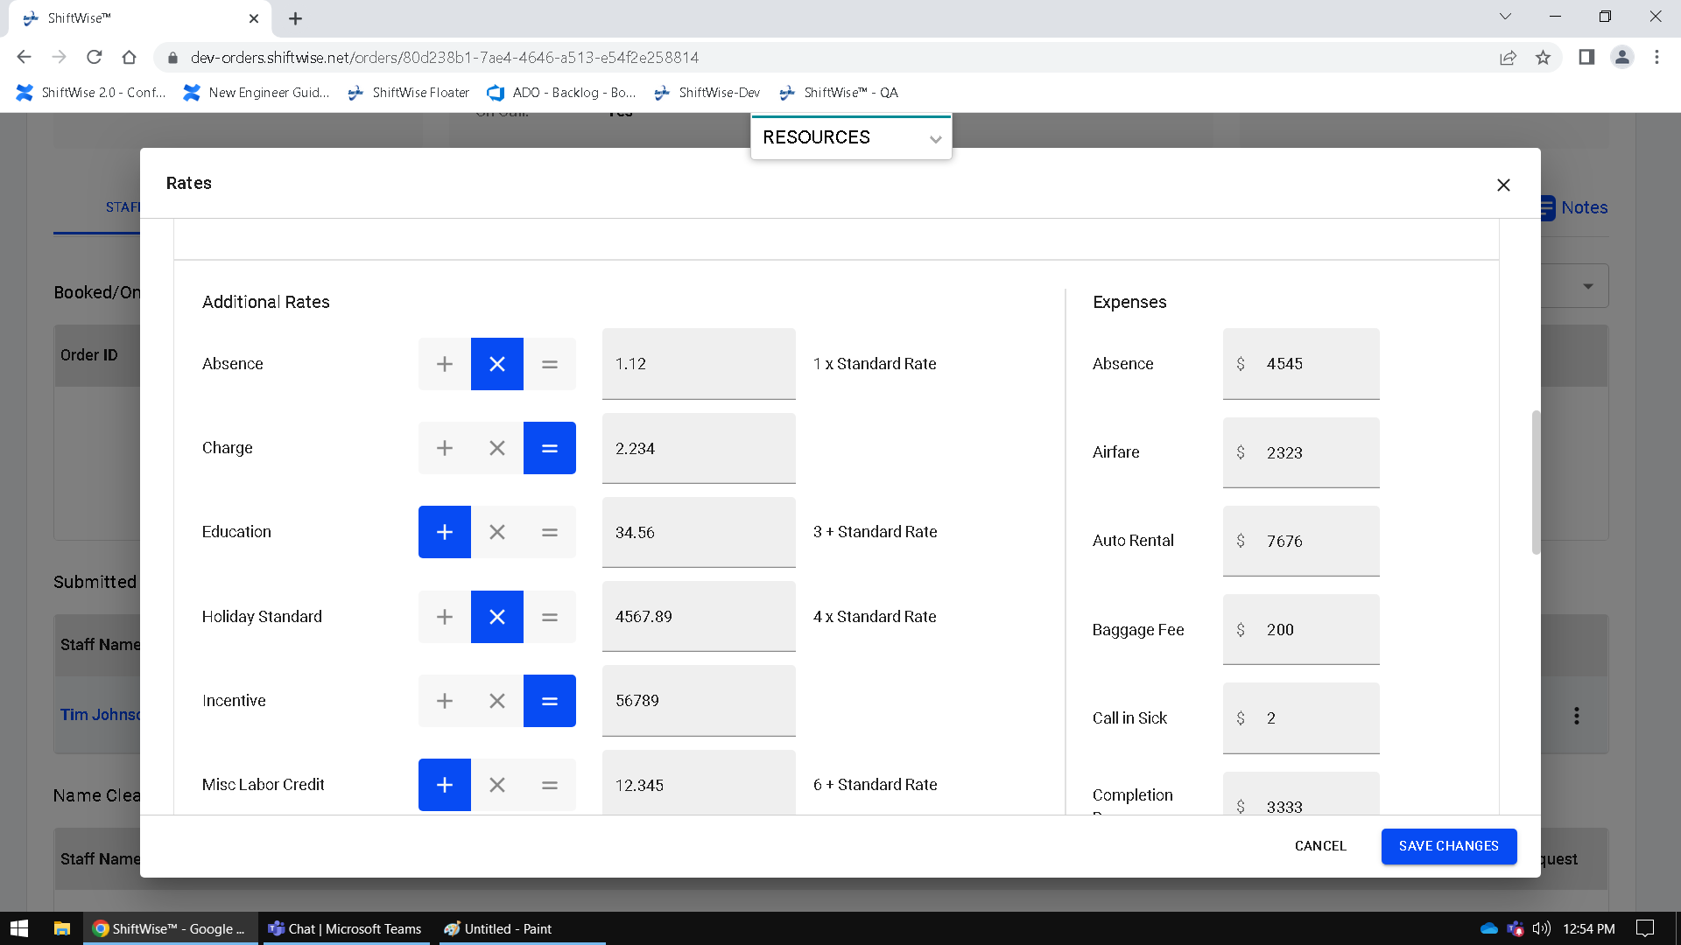

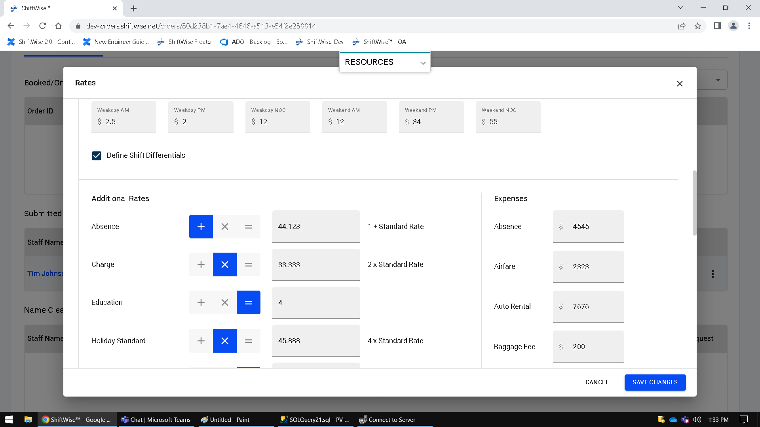

1. Modifier selection is getting auto changed when user change the modifier of first Additional Rate value.

Order ID: 10173904

Rateset with effective date: 01/20/2023

1. a